02 Overview 02 – MLA Manuscript Format: The Humanities Standard

Writing in the Humanities—in disciplines such as English, literary studies, philosophy, cultural studies, foreign language studies, and other related subjects—is often presented in a common manuscript format and organization, created by the members of the Modern Language Association (MLA), the professional governing body for studies in language and literature. This manuscript format makes it easy for practitioners in these disciplines—students, scholars, editors, and yes, even English 101 teachers—to gather reliable basic information about what they are reading, the writer who performed it, and the circumstances under which it was created.

The Freshman English Composition program requires that all formal writing assignments in English 101 and 102 adhere to MLA Manuscript Format guidelines.

MLA Manuscript Format: The Basics
An MLA Manuscript Format paper conforms to the following guidelines:
- All pages are in 12 Point Times New Roman Font.
- All pages have one inch margins on all sides.
- All pages are double spaced.
- All pages have a running header (top right) consisting of the author’s last name and the page number.
- The first page has a title and heading with the author’s name, the paper’s title, the date, and the instructor’s name.
- If the document includes cited sources, it contains a properly-formatted Works Cited page.

Formatting in MLA Style Using Microsoft Word

Step 1: Set the Font to Times New Roman 12

- Before you begin typing, click on the drop-downs in the Home tab that list the Font name (such as Times New Roman, Calibri, etc.) and the point size (12).
- Select Times New Roman from the font name drop down, and “12” from the point size drop down.
- If you already have text typed into your document, select it, and then set the font to Times New Roman. To select all the text in your document, choose Select / All from the menu on the far right of the Home tab.
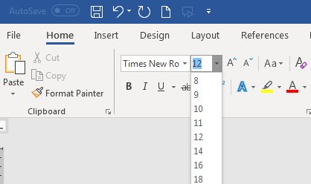
Figure 1: Setting the Font
Step 2: Set Top, Bottom, Right, and Left Margins to 1"
- To set the margins, select the Page Layout tab.
- Click on the "Margins" icon.
- Choose the "Normal" margin setting (1" for each of the margin settings).
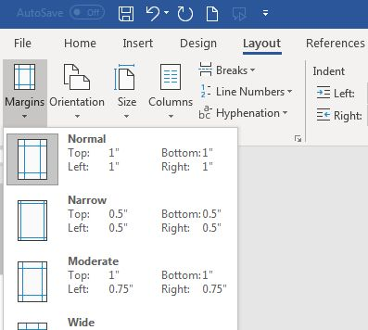
Figure 2: Formatting the Margins

Step 3: Set line spacing to double spaced.
- On the Home tab, click the arrow to the right of "Paragraph"
- Under "Line Spacing," select "Double."
- Make sure both Before and After spacing are set to 0 pts.
- Click OK.
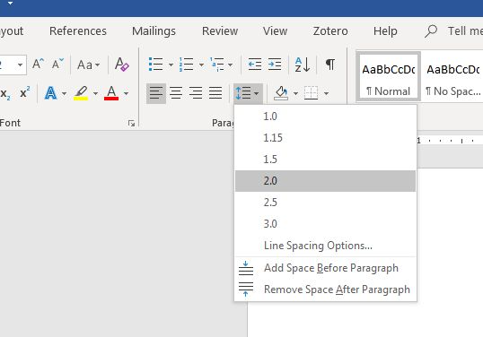
Figure 3: Set line spacing to double spaced.

Step 4: Create a Header with your last name and the page number.

Every page of a manuscript in MLA format has a header in the upper right-hand corner of the manuscript, approximately 1/2" from the top of the page. To create the header and set the page numbering to automatically increment each page:
- From the Insert tab, select Page Number and Top of Page.
- Choose "Plain Number 3" (see Figure 3).
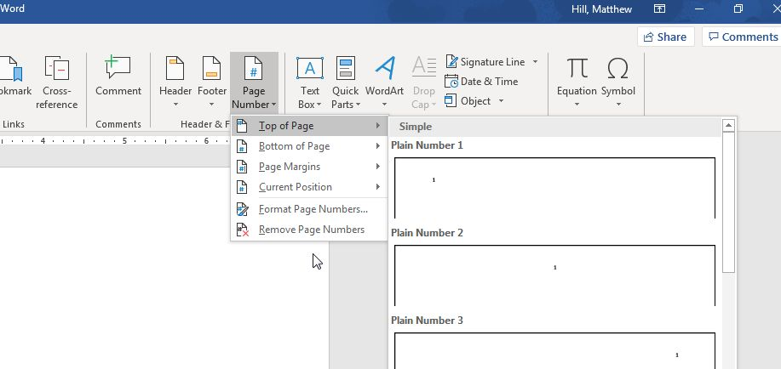
Figure 4: Set the header page number.
4. Use the left arrow to move one space to the left of the page number; type your last name and a single blank space.
5. Double click outside of the "header" box to return to your document.
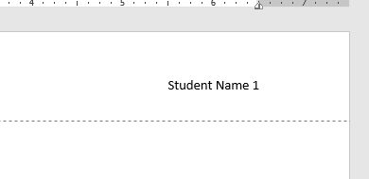
Figure 5: Creating a header with your last name and the page number

Step 5: Enter the Title and Heading Block
- Go to the top left corner of your document—not in the header, but in the main body of the document.
- Type your name and then press the Enter key once.
- Type your professor's name, and then Enter.
- Type the course identification, and then Enter.
- Type the date. Press the Enter key once only.
- Click on the Align Center icon in the Home tab (under “Paragraph”).
- Type the title of your paper, capitalizing the first word and all major words and proper nouns. Do not use italics, boldfaced type, underlining, or all caps to format your title. Do not type a period at the end of the title. Press the Enter key once.
- Click on the Align Left icon in the Home tab (under “Paragraph”).
- Depress the Tab key to indent 1/2 inch to begin your first paragraph and begin typing your document. (See Figure 6 for an example of a properly-formatted MLA-style manuscript.)
Note: Do not hit the return or enter key at the end of a line; allow the word processor to automatically wrap the text to the next line. Depress the enter key only once at the end of each paragraph, and use the tab key to begin a new paragraph.
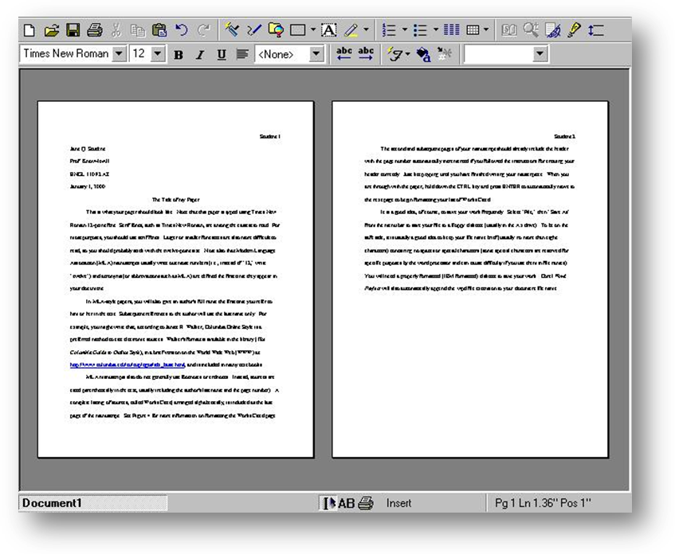
Figure 6: A properly formatted MLA-Style paper.
Step 6: Format the Works Cited page

Immediately after typing the final line of your paper, depress the CTRL key and the ENTER key at the same time. This will take you to the first line at the top of the next page. Your header and page number should already appear.
- On the "Home" tab, click on the Align Center icon.
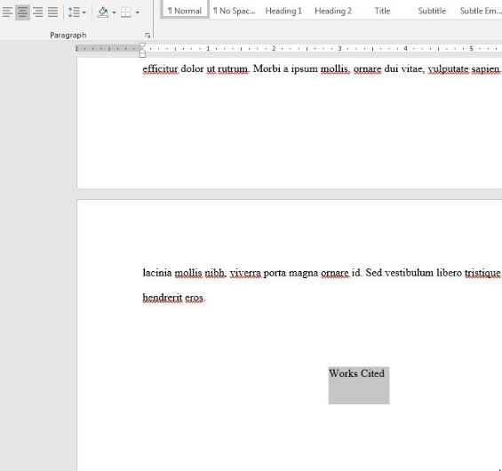
Figure 7: Center the "Works Cited" title..
- Type Works Cited (do not underline, boldface, italicize, or enclose in quotes).
- Depress the Enter key once.
- Click on the Align Left icon on the Home tab (under “Paragraph”).
- On the Home tab, click the arrow to the right of "Paragraph."
- Under "Special," select "Hanging."
- Click OK.
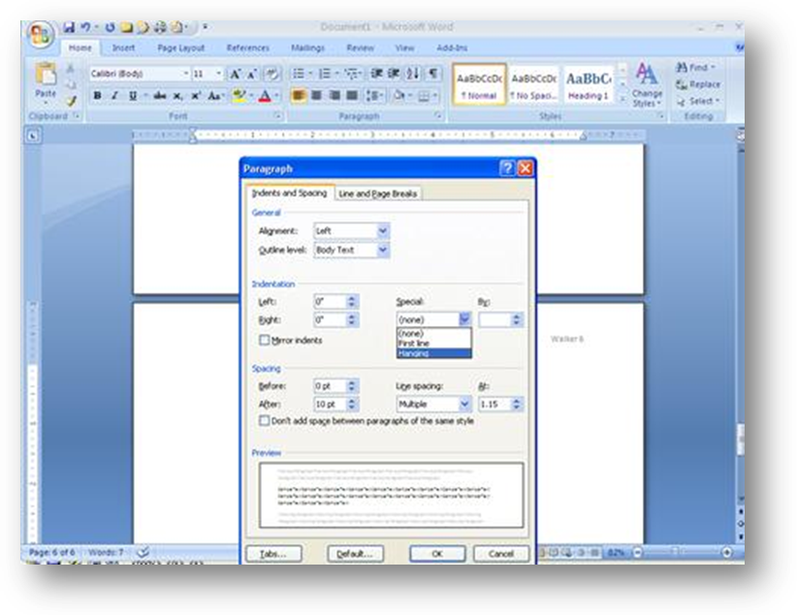
Figure 8: Set "Hanging indents."

- Type your first works cited entry, using the appropriate MLA Style Works Cited citation style. See Chapter 08 in this text for the proper citation formats.
- At the end of each entry, depress the Enter key only once. Do not introduce extra spaces between entries!
- Repeat steps 5, 6, and 7 for each entry.
- A properly formatted MLA style Works Cited page is shown in Figure 9, below.
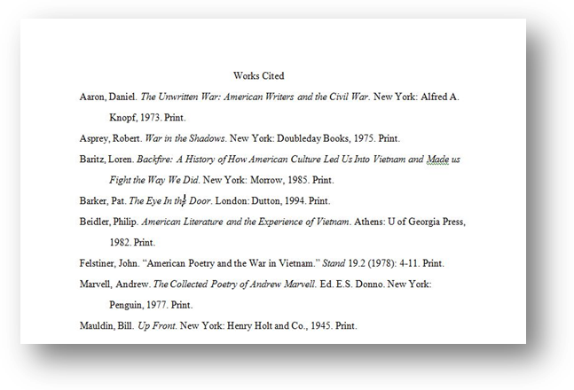
Figure 9: A properly-formatted Works Cited page in MLA format.

