024 Grammar 05 - Possession

To “possess” something is to show ownership of it. This ownership could be the literal owning of an object, such as owning a house, car, or box full of pencils:

Behind the auto parts store is Jamie’s house.

John’s car was found in East Memphis, Tennessee; it seems someone took it on a road trip without telling him.

Marina’s box full of pencils was sitting on the shelf in the classroom.

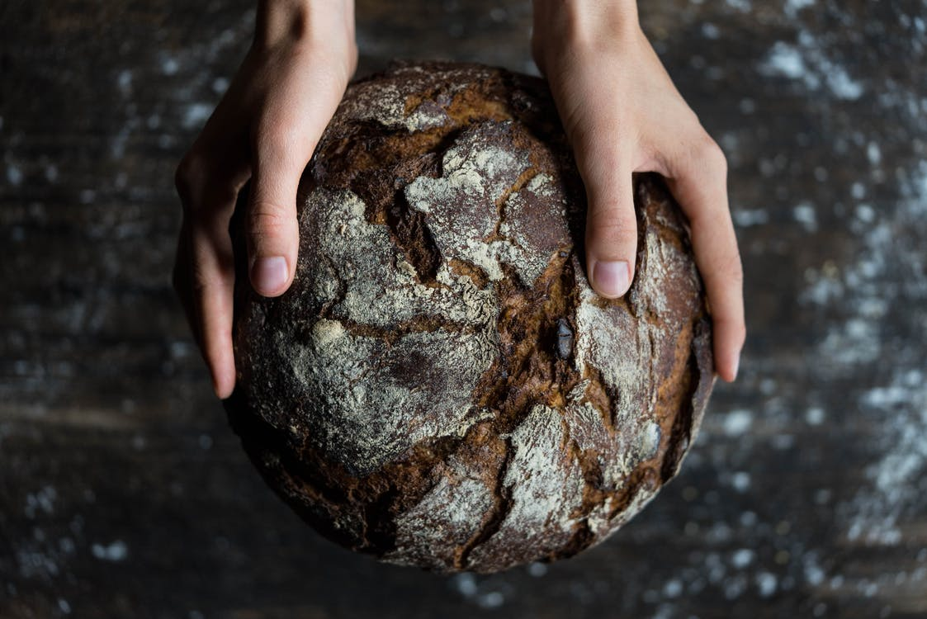
But possession can also be relational or metaphorical, such as “having” another person (a friend, family member, or other relation), a commitment, or an abstract idea:

John’s girlfriend plays in a punk-rock band called Pink Violence; they are terrible.

Jasmine’s father was sick last week with the stomach flu, but he is much better now.

Arnold and Connie’s chemistry class was extremely difficult this morning.

Kevin’s session begins at four p.m., and he should not be late for it.

Montague’s theory of familial relationships differs strikingly from Capulet’s looser formulation of provisional social bonding.

Poetry’s emotional intensity is its strongest selling point; the novel’s breadth and complexity is its bread and butter.

In most dialects of English, including Standard English Grammar, the most common method of indicating possession is the use of the apostrophe (’) and the letter “s.” Where the apostrophe goes depends most of the time on whether the possessor is singular or plural.

NOTE: Adding an apostrophe and “s” to a word does not make it a plural, despite common spellings on street advertisements.

For a singular possessor (a single subject), the apostrophe is placed between the end of the possessor and the “s” that indicates possession:

The boy’s toy rocketship got broken.

The Girl Scout troop’s cookies were delicious.

The horse’s tail was wagging back and forth.

John’s house needs some new windows.

Pete’s class met in the library yesterday to begin their research projects.

My teacher’s mannerisms are a little unconventional, but interesting.

The bakery’s pastries are phenomenal, but they are extremely bad for one’s health.

You’ll notice that it does not matter if the objects that these possessors possess are plural—the troop’s cookies, the teacher’s mannerisms, and bakery’s pastries are all plural objects. The possession is still indicated with an apostrophe and “s.”

Exercise: Possession / Singular Possessor

Identify whether or not each of the possessive forms below is correct to indicate a singular possessor.

- Wanda’s midterm was a bit more challenging than she had expected. Correct? Y / N
- Julias pigtails came undone on the playground yesterday. Correct? Y / N
- Miranda borrowed Rachel textbook without telling her. Correct? Y / N
- Bob’s mother was in the doctor’s office yesterday, and is in perfect health. Correct? Y / N
- The police departments’ evidence was pretty weak in that particular case. Correct? Y / N
- The angry chef yelled at his assistant for the kitchen’s appearance. Correct? Y / N
- My watches second hand stopped yesterday; I don’t know how to fix it. Correct? Y / N
- While we were on our whale-watching trip a gray whale’s spray got my wife and me all wet, and we smelled like seawater for days. Correct? Y / N
- In the chaos of last fall’s Halloween party, someone accidentally stepped through Toms bass drum. Correct? Y / N
- The Peabody Conservatory’s reputation for excellence is well known. Correct? Y / N

When the possessors are plural, however —when more than one person owns the item in question—the way we indicate possession slightly differently, shifting the place of the apostrophe to after the “s” in the plural subject. Here are some examples:

The boys’ toy rocketship got broken when they were fighting over it.

The horses’ tails swayed back and forth as they trotted up the trail.

The horses’ stable was a short walk from the barn.

The chickens’ beaks pecked at the grain in their pen.

My teachers’ quizzes are challenging.

My teachers’ dedication to my academic success impresses and inspires me.

While some objects are necessarily logically plural here (chickens’ beaks, horses’ tails, teachers’ quizzes), because multiple chickens cannot own the same beak, multiple horses cannot own a single tail etc., it is the possessors’ plurality that is the deciding feature.

Placing the apostrophe incorrectly can cause much confusion in the clarity and overall meaning of a sentence, as in the following examples:

The boy’s parents were angry. | The set of parents of a single boy were angry.
The boys’ parents were angry. | Either: The single set of parents of a set of boys (brothers) were angry, or multiple sets of the parents of multiple boys were angry.
I wrecked my parents’ car after prom. | The speaker wrecked the jointly-owned car of his parents.
I wrecked my parent’s car after prom. | The speaker wrecked the car belonging to either his father or his mother.

Compound and Irregular Subjects

Compound subjects—usually two singular possessors connected by a conjunction (most often “and”) are most often treated as one singular possessor for determining the possessive form. The apostrophe “s” goes after the second possessor.

Casey and Michaela’s project was very interesting.

Andrea and her grandmother’s trip to New York was scheduled for last weekend, but the weather didn’t cooperate.

Tanya and Roberta’s rooms were a mess, and their mothers told them to clean them up immediately.

Tanya and Roberta’s room was a mess, and their mother told them to clean it up immediately.

The paper and the radio station’s business had been failing for some time before the bankruptcy.

My mother and father’s disagreement over whether or not to give me their old car caused a lot of stress during my senior year in high school.

My mother and father’s disagreements over whether or not to give me their old car caused a lot of stress during my senior year in high school.

Exercise: Possession / More Complex Possessors

Identify and correct the errors in possession in the sentences below. Each sentence has at least one error.

- The cars’ windshield was broken by the stone that fell off the truck.
____________________________________________________________________
- The state lawmakers’ argument was over the best way to fix Alabama economy.
____________________________________________________________________
- When Carl went back into the classroom, he found Laurens purse and jacket.
____________________________________________________________________
- Zora and Lucille chili is the best in the state; their living room is full of trophies that say so.
____________________________________________________________________
- The chairs legs were wobbly and needed to have their bolts replaced.
____________________________________________________________________
- Anthonys’ problem was that he just didn’t agree with the district managers assessment of the company’s situation.
____________________________________________________________________
- After watching television for a couple of hours, we all went back to Andrea house for a snack.
____________________________________________________________________
- All fourteen of the pigs tails were curly.
____________________________________________________________________
- The technician message told me that my computers’ motherboard was fried and needed to be replaced.
____________________________________________________________________
- My professors comments told me that my essay’s introduction needed work and that the essay format was wrong.
____________________________________________________________________

